GWCS NAVY BLUE ZIP HOODIE
ORDER FORM Due Wed., March 9th!
YOUR NAME:
SIZE: | X-Small | Small |  | Medium |  | Large |  | X-Large |  | XX-Large
QUANTITY:
PERSONALIZATION:
See where Goldie is
pointing in first photo!
COST: | $40.00/EACH |  | TOTAL # HOODIES ORDERED: |  |  |  | TOTAL $ ENCLOSED:

 | 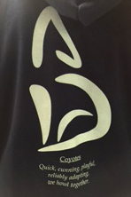 | 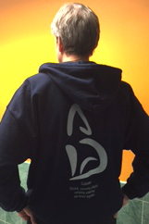
Personalization: See where Mr. Goldie is pointing in the first photo? That is where you can have your name embroidered. His just says “Goldie” but yours could say “Burrito O’Grady” or whatever you prefer. If you do not want any personalization, please put an ‘X’ in the box so we know you didn’t forget.
Haiku for year # 17 - Coyotes: Quick, cunning, playful, reliably adapting, we howl together.

